**HOW TO PLAY??**

1. **Click on the start button.**

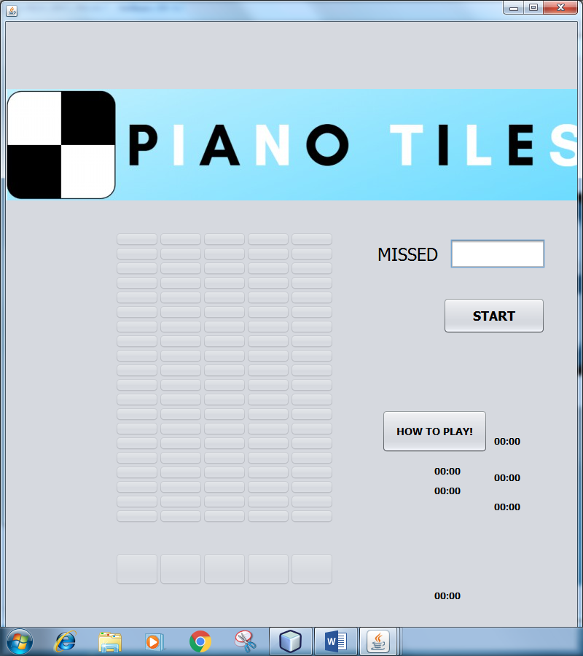

1. **Place the cursor on one of the bottom 5 button from where it is falling from.**

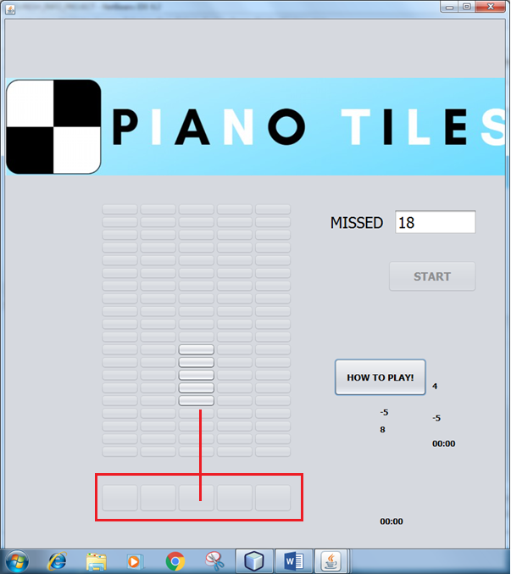

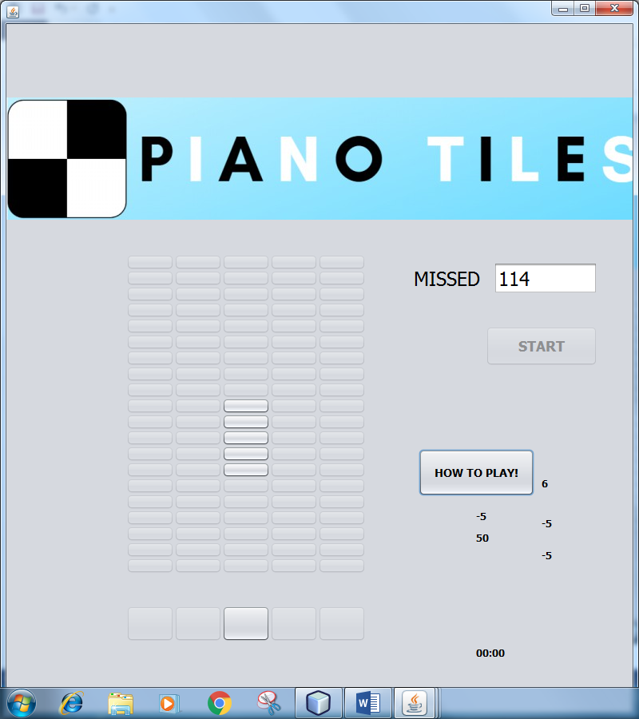

**ENJOY!!!^_^**